**Web Technology**

**Naresh Kumar**

**22IT3025**

**Lab-5**

T1 :

<!DOCTYPE html>

<html lang="en">

<head>

<meta charset="UTF-8">

<meta name="viewport" content="width=device-width, initial-scale=1.0">

<title>Naresh's T1</title>

<style>

body {

display: flex;

align-items: center;

justify-content: center;

height: 100vh;

margin: 0;

}

h2 {

font-family: 'Arial', sans-serif;

text-align: center;

transition: transform 0.5s ease-in-out;

}

.spin {

animation: spin 0.5s ease-in-out;

}

@keyframes spin {

0% {

transform: rotate(0deg);

}

100% {

transform: rotate(360deg);

}

}

input {

padding: 5px;

margin-right: 10px;

}

button {

padding: 5px 10px;

}

</style>

</head>

<body>

<div>

<h2 id="displayText">Hello</h2>

<input type="text" id="inputText" placeholder="Type a word or phrase">

<button onclick="changeText()">Change Text</button>

</div>

<script>

function changeText() {

var inputElement = document.getElementById('inputText');

var displayElement = document.getElementById('displayText');

var newText = inputElement.value.trim();

displayElement.innerText = newText;

displayElement.classList.add('spin');

setTimeout(function() {

displayElement.classList.remove('spin');

}, 500);

}

</script>

</body>

</html>

OUTPUT

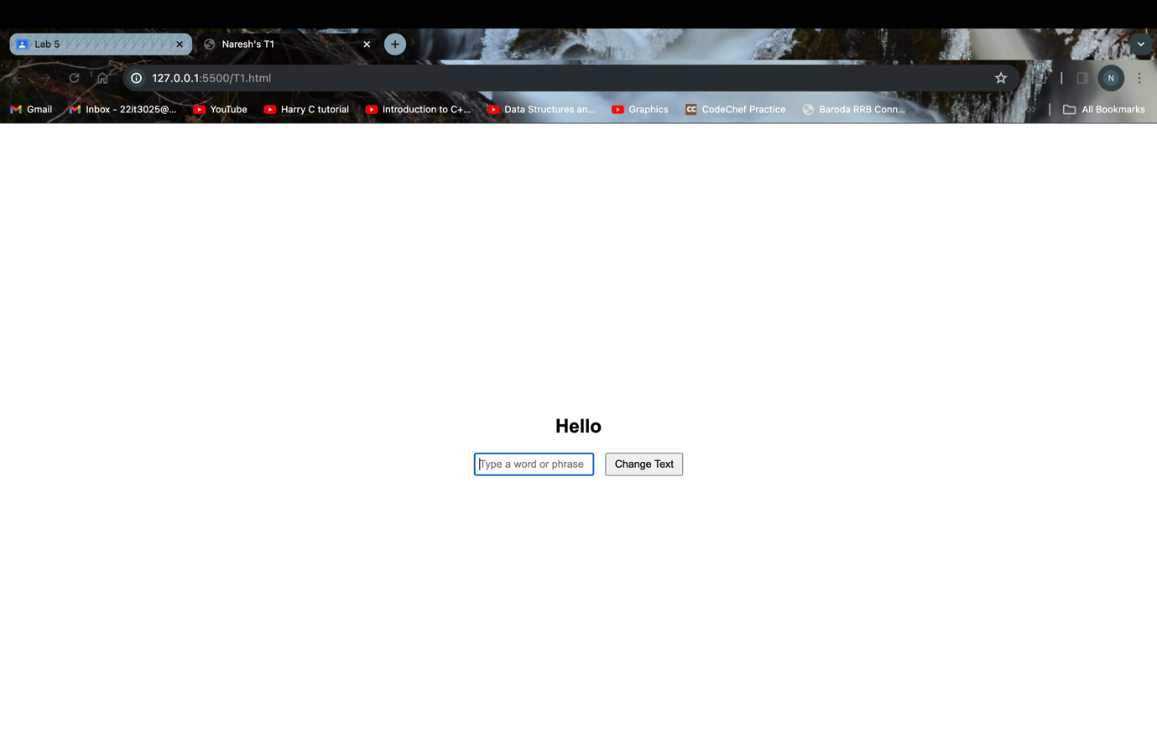

T2:

<!DOCTYPE html>

<html lang="en">

<head>

<meta charset="UTF-8">

<meta name="viewport" content="width=device-width, initial-scale=1.0">

<title>Naresh's T2</title>

<style>

body {

margin: 0;

}

button {

padding: 10px;

font-size: 16px;

}

#count, #countDisplay {

font-size: 16px;

margin-left: 10px;

}

</style>

</head>

<body>

<div>

<button onclick="incrementCount()">Increment Count</button>

<p id="count">0</p>

<p id="countDisplay">Count = 0</p>

</div>

<script>

var count = 0;

function incrementCount() {

count++;

updateCount();

}

function updateCount() {

var countElement = document.getElementById('count');

var countDisplayElement = document.getElementById('countDisplay');

countElement.innerText = count;

countDisplayElement.innerText = 'Count = ' + count;

countDisplayElement.style.fontSize = (count + 7) + 'px';

}

</script>

</body>

</html>

OUTPUT

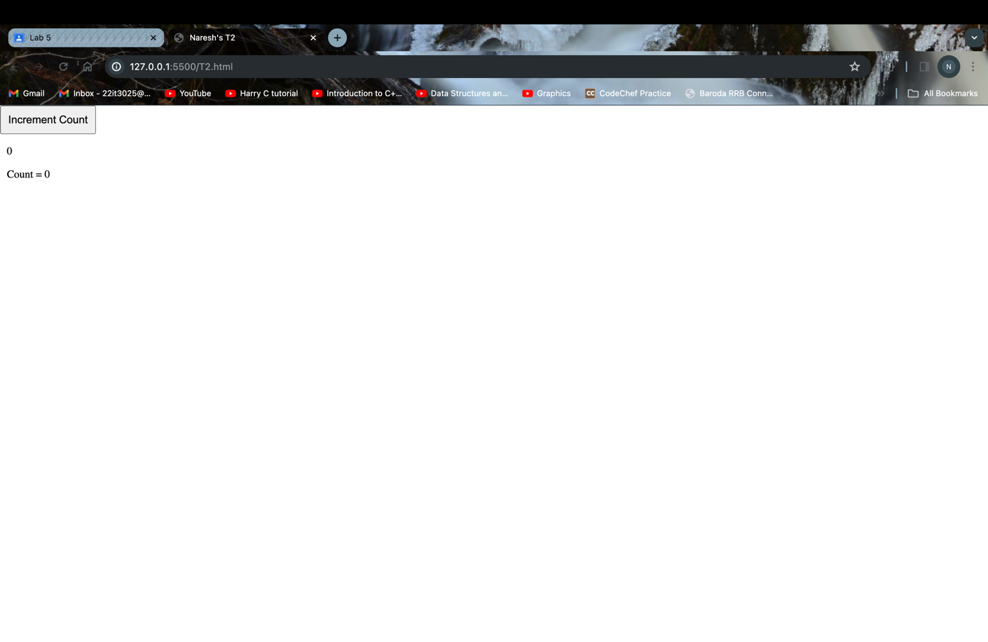

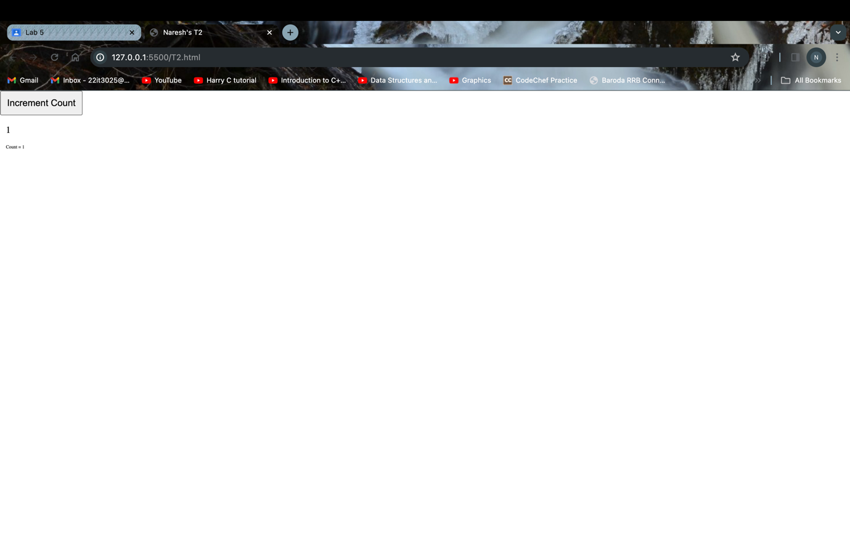

T3:

<!DOCTYPE html>

<html lang="en">

<head>

<meta charset="UTF-8">

<meta name="viewport" content="width=device-width, initial-scale=1.0">

<title>Naresh's T3</title>

<style>

body {

margin: 0;

}

button {

padding: 10px;

font-size: 16px;

}

#countList {

list-style-type: none;

padding: 0;

}

.countItem {

font-size: 16px;

margin-left: 10px;

}

</style>

</head>

<body>

<div>

<button onclick="incrementCount()">Increment Count</button>

<ul id="countList"></ul>

</div>

<script>

var count = 0;

function incrementCount() {

count++;

updateCount();

}

function updateCount() {

var countList = document.getElementById('countList');

var listItem = document.createElement('li');

listItem.className = 'countItem';

listItem.innerText = 'Count = ' + count;

countList.appendChild(listItem);

}

</script>

</body>

</html>

OUTPUT

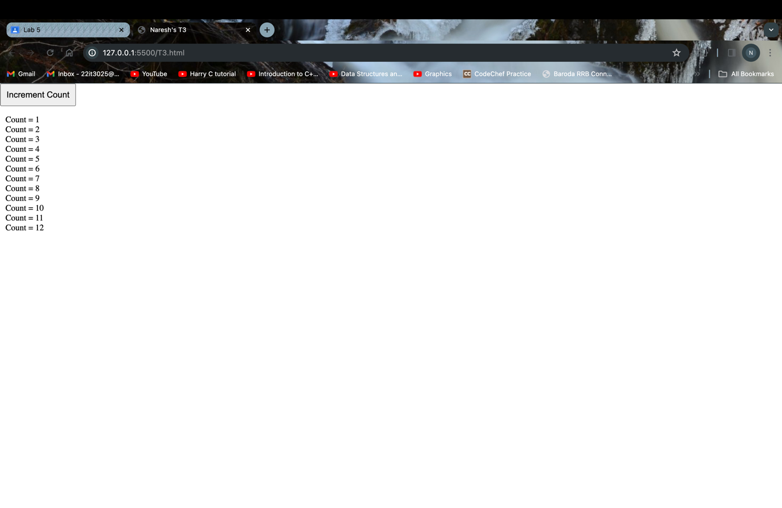

T4:

<!DOCTYPE html>

<html lang="en">

<head>

<meta charset="UTF-8">

<meta name="viewport" content="width=device-width, initial-scale=1.0">

<title>Naresh's T4</title>

<style>

table {

border-collapse: collapse;

width: 300px;

margin: 20px;

}

th, td {

border: 1px solid black;

padding: 8px;

text-align: center;

}

</style>

</head>

<body>

<table id="sumTable">

<thead>

<tr>

<th>Row</th>

<th>Sum</th>

</tr>

</thead>

<tbody>

<tr>

<td>1</td>

<td>0</td>

</tr>

<tr>

<td>2</td>

<td>1</td>

</tr>

</tbody>

</table>

<button onclick="addRow()">Add Row</button>

<script>

function addRow() {

var table = document.getElementById('sumTable').getElementsByTagName('tbody')[0];

var rows = table.getElementsByTagName('tr');

var lastRow = rows[rows.length - 1];

var secondLastRow = rows[rows.length - 2];

var lastValue = parseInt(lastRow.lastElementChild.innerText) || 0;

var secondLastValue = parseInt(secondLastRow.lastElementChild.innerText) || 0;

var sum = lastValue + secondLastValue;

var newRow = document.createElement('tr');

var cell1 = document.createElement('td');

cell1.innerText = rows.length + 1;

var cell2 = document.createElement('td');

cell2.innerText = sum;

newRow.appendChild(cell1);

newRow.appendChild(cell2);

table.appendChild(newRow);

}

</script>

</body>

</html>

OUTPUT

T5:

<!DOCTYPE html>

<html lang="en">

<head>

<meta charset="UTF-8">

<meta name="viewport" content="width=device-width, initial-scale=1.0">

<title>Naresh's T5</title>

<style>

body {

display: flex;

flex-direction: column;

align-items: center;

justify-content: center;

height: 100vh;

margin: 0;

font-family: Arial, sans-serif;

}

input {

margin: 5px;

padding: 8px;

width: 200px;

}

button {

margin: 5px;

padding: 10px;

font-size: 16px;

}

#result {

margin-top: 10px;

font-size: 18px;

}

</style>

</head>

<body>

<input type="text" id="input1" placeholder="Enter number 1">

<input type="text" id="input2" placeholder="Enter number 2">

<button onclick="performOperation('+')">+</button>

<button onclick="performOperation('-')">-</button>

<button onclick="performOperation('*')">*</button>

<button onclick="performOperation('/')">/</button>

<div id="result"></div>

<script>

function performOperation(operator) {

var input1 = document.getElementById('input1').value;

var input2 = document.getElementById('input2').value;

var num1 = Number.parseInt(input1);

var num2 = Number.parseInt(input2);

if (isNaN(num1) || isNaN(num2)) {

alert("Please enter valid numbers");

return;

}

var result;

switch (operator) {

case '+':

result = num1 + num2;

break;

case '-':

result = num1 - num2;

break;

case '*':

result = num1 * num2;

break;

case '/':

if (num2 === 0) {

alert("Cannot divide by zero");

return;

}

result = num1 / num2;

break;

default:

alert("Invalid operation");

return;

}

document.getElementById('result').innerText = 'Result: ' + result;

}

</script>

</body>

</html>

OUTPUT

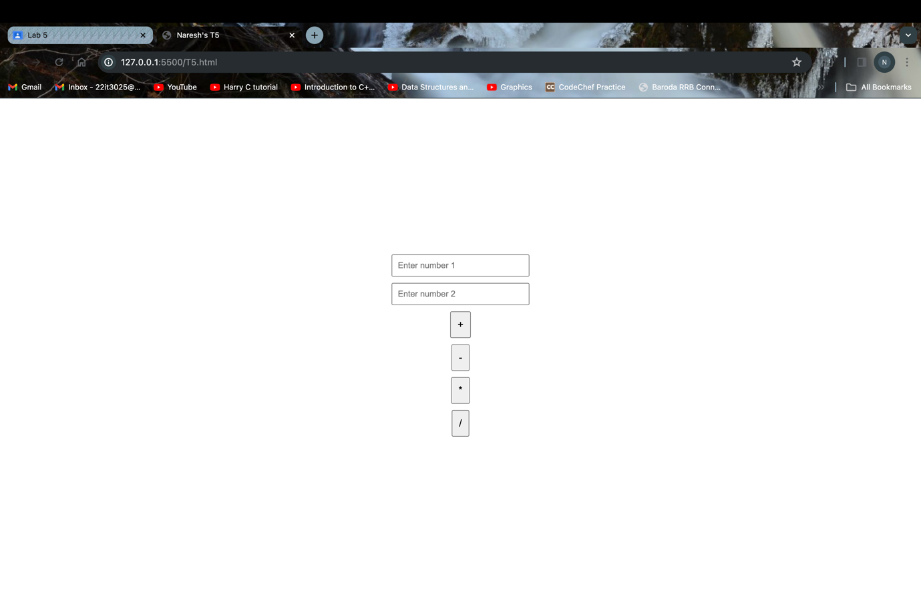

when + button is clicked

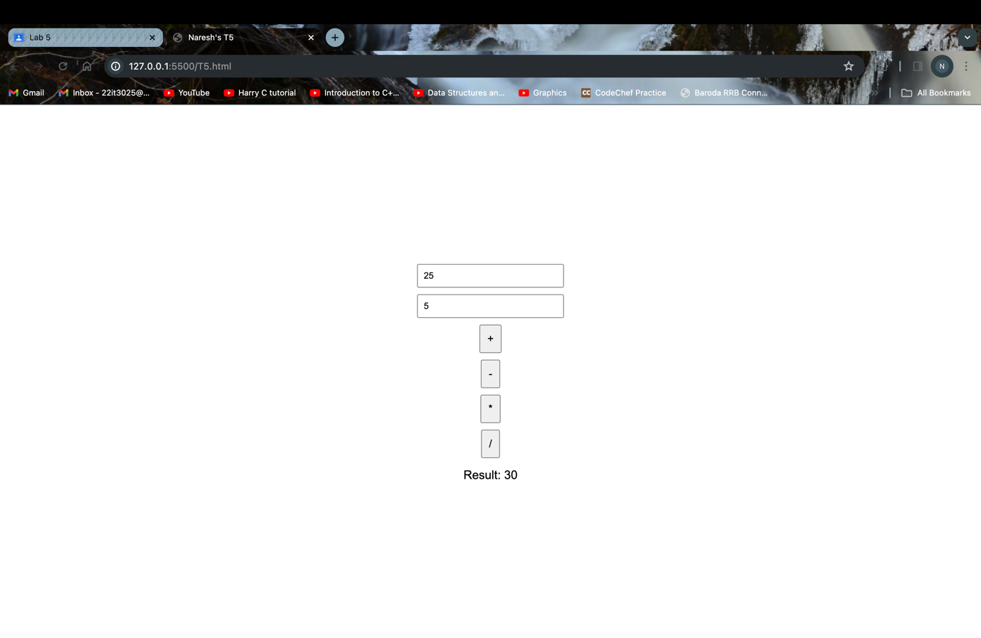

when - button is clicked

when * button is clicked

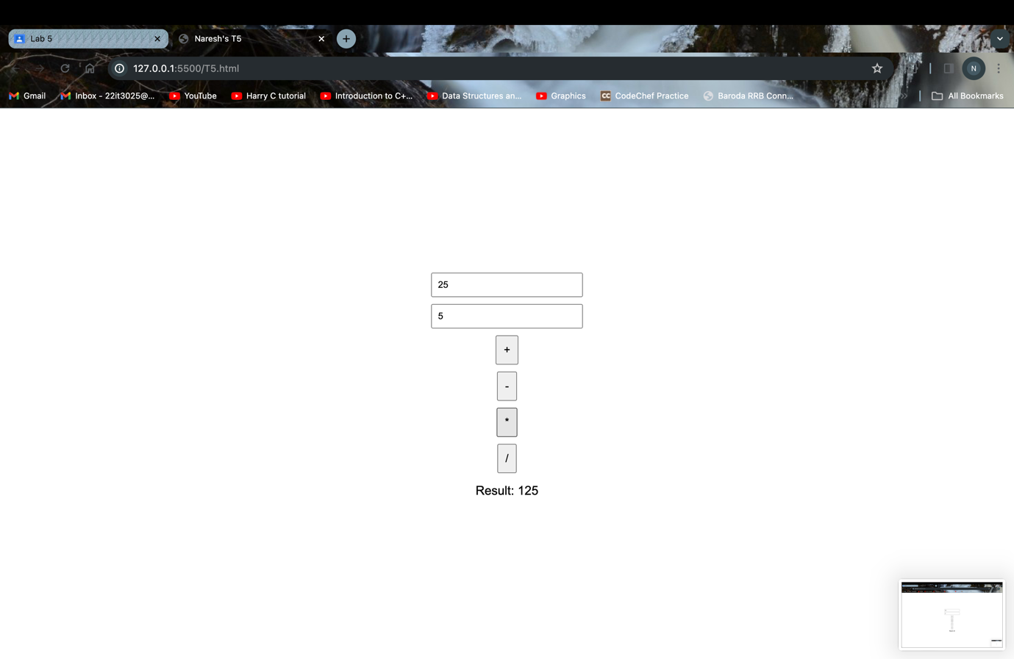

when / button is clicked

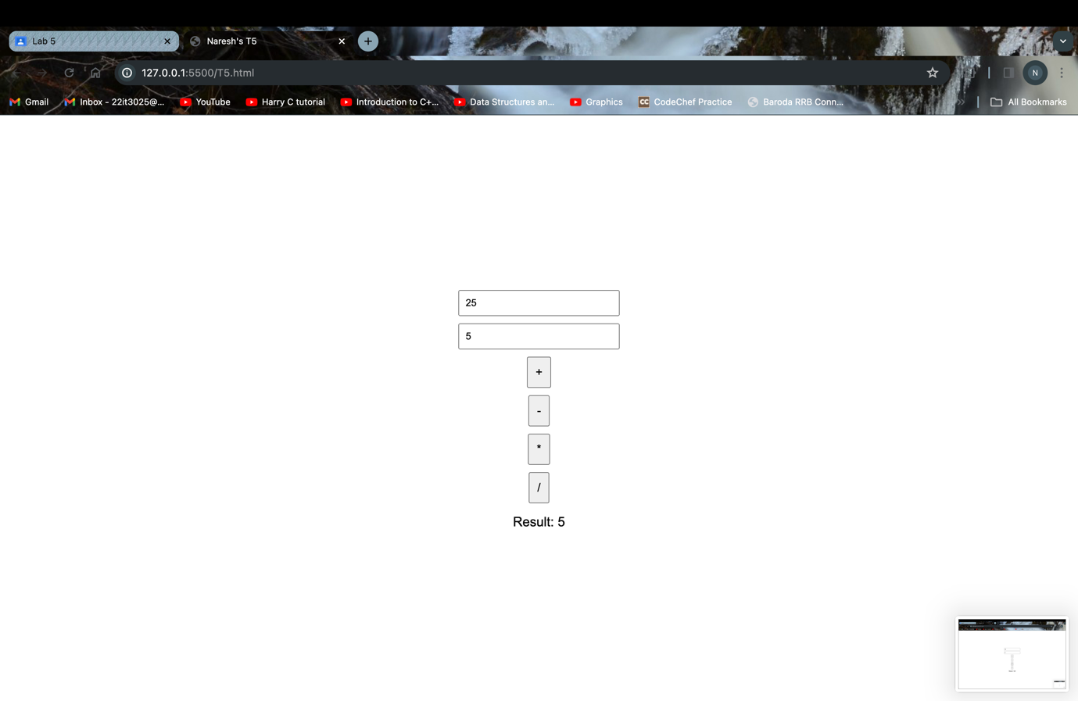

T7:

<!DOCTYPE html>

<html lang="en">

<head>

<meta charset="UTF-8">

<meta name="viewport" content="width=device-width, initial-scale=1.0">

<title>Naresh's T7</title>

<style>

body {

font-family: Arial, sans-serif;

display: flex;

align-items: center;

justify-content: center;

height: 100vh;

margin: 0;

background-color: #f4f4f4;

}

#calculator {

text-align: center;

padding: 20px;

border: 1px solid #ccc;

border-radius: 8px;

background-color: #fff;

box-shadow: 0 0 10px rgba(0, 0, 0, 0.1);

}

label {

display: block;

margin-bottom: 10px;

font-weight: bold;

}

input {

width: 100%;

padding: 10px;

margin-bottom: 20px;

box-sizing: border-box;

}

#result {

font-size: 18px;

font-weight: bold;

}

</style>

</head>

<body>

<div id="calculator">

<label for="totalAmount">Total Amount</label>

<input type="number" id="totalAmount" placeholder="Enter total amount">

<label for="tipPercentage">Tip Percentage</label>

<input type="range" id="tipPercentage" min="0" max="30" step="1" value="15">

<span id="tipPercentageValue">15%</span>

<label for="numOfPeople">Number of People</label>

<input type="number" id="numOfPeople" placeholder="Enter number of people" value="1">

<button onclick="calculateTip()">Calculate Tip</button>

<div id="result"></div>

</div>

<script>

function calculateTip() {

var totalAmount = parseFloat(document.getElementById('totalAmount').value) || 0;

var tipPercentage = parseInt(document.getElementById('tipPercentage').value);

var numOfPeople = parseInt(document.getElementById('numOfPeople').value) || 1;

var tipAmount = (totalAmount * tipPercentage) / 100;

var totalWithTip = totalAmount + tipAmount;

var perPersonAmount = totalWithTip / numOfPeople;

var resultText = `

Tip Amount: Rs${tipAmount.toFixed(2)}<br>

Total with Tip: Rs${totalWithTip.toFixed(2)}<br>

Per Person: Rs${perPersonAmount.toFixed(2)}

`;

document.getElementById('result').innerHTML = resultText;

}

document.getElementById('tipPercentage').addEventListener('input', function() {

document.getElementById('tipPercentageValue').innerText = this.value + '%';

});

</script>

</body>

</html>

OUTPUT

